Rayhanur Rahman , StudentID = W2073057

Entities , keys and relationships:

|  |  |  |  |
| --- | --- | --- | --- |
| Entity | Primary Key | Foreign key | Rationale for PK |
| gsCUSTOMER | customer_id | N/A | Customer id is unique for each customer |
| gsORDER | order_id | customer_id | Order id is unique for each order |
| customer_order | Customer_id , order_id | Customer_id , order_id | Customer_order is a link entity and a minimum PK is a  composite key made  up of parent PKs as  as well as being FKs. |
| gsITEM | itemID | product_id | itemID is unique for each ID |
| GSorder_item | Order_id , itemID | Order_id , itemID | Item_order is a link entity and a minimum PK is a  composite key made  up of parent PKs as  as well as being FKs. |
| gsPRODUCT | product_id | N/A | Product_id is unique for each product |
| product_item | product_id , itemID | Product_id, itemID | Product_item is a link entity and a minimum PK is a  composite key made  up of parent PKs as  as well as being FKs. |
| gsDEPARTMENT | department_id | N/A | Each department has their own ID which is unique to the department |
| gsEMPLOYEE | employee_id | department_id | Each employee has their own ID which is unique |
| gsSALESPEFORMANCE | peformance_id | employee_id | Each employee has their own performance_id which is unique to them |
|  |  |  |  |

ERD DIAGRAM:

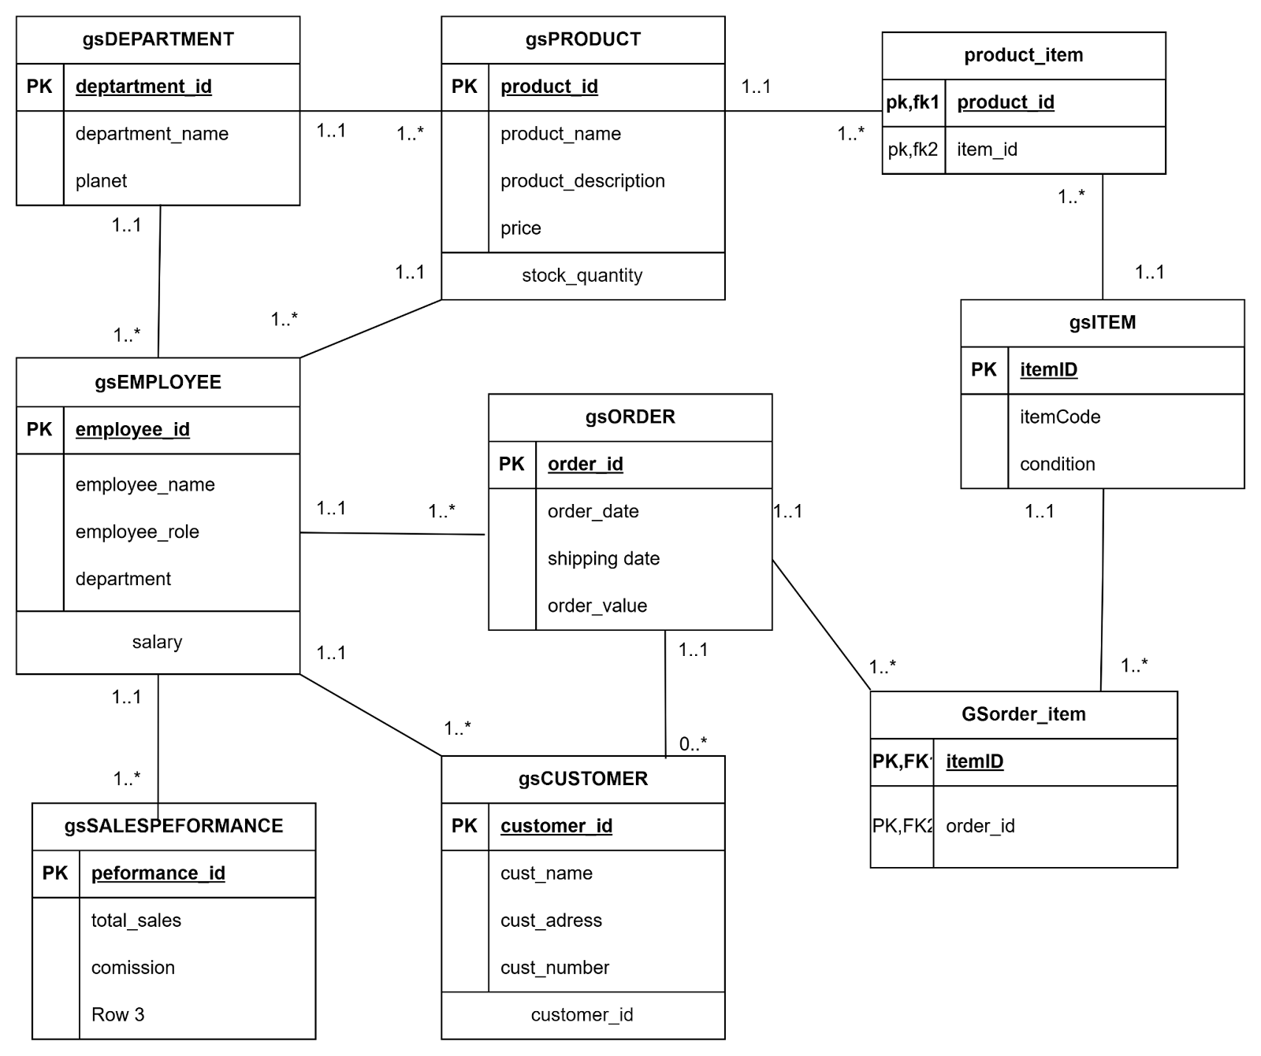

**Relationships between Entities:**

A customer can place many orders (One-to-Many relationship). Each order belongs to a specific customer. Some customers may not place an order.

An order can include multiple items. The Item_Order is a relationship table that links orders to the items being purchased. An order may consist of many items, and each item can appear in many orders so there's a many to many relationship between item and order.

The product manufacturing department is responsible for creating the product, other departments can promote the products so there is a One-to-Many relationship.

An employee's performance can be tracked through sales performance metrics so it is a One-to-Many relationship from Employee to SalesPerformance.

Each employee works in a department so there is a Many-to-One relationship. Departments have at least one employee and can have many employees

Employees process orders , employees can process multiple orders.

Employees interact with customers as some employees are salesmen and would promote the products and influence customers to buy the product.

Employees create the product , many employees work on a product.

A product can have multiple items and an item can be associated with multiple products , since the relationship is many to many , we need to make another entity to link the two called product_id.

SQL TABLE CREATION:

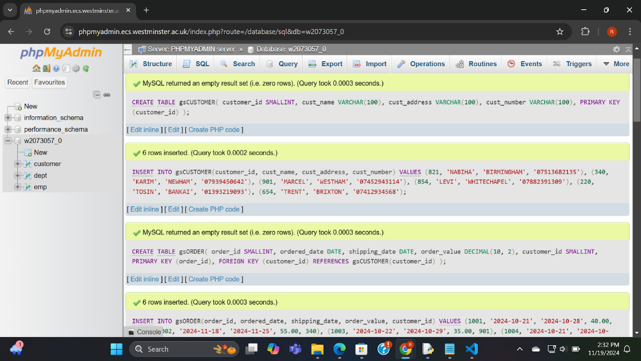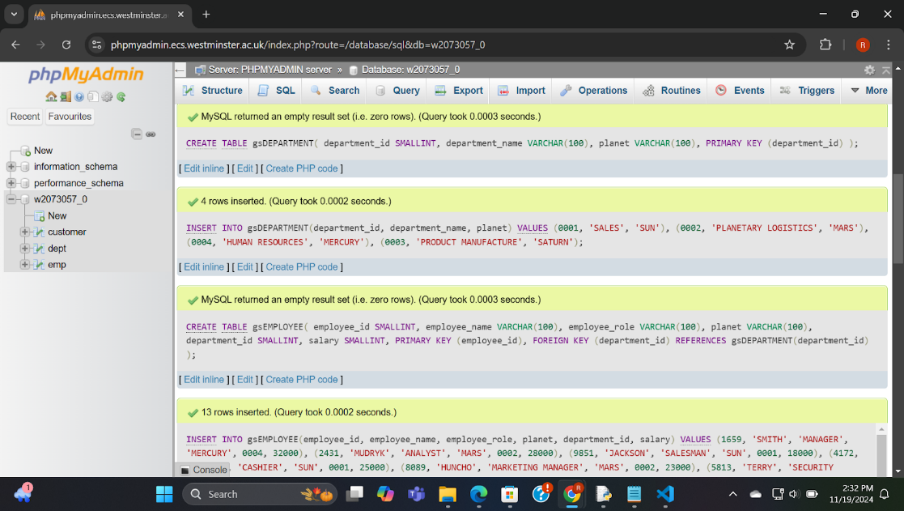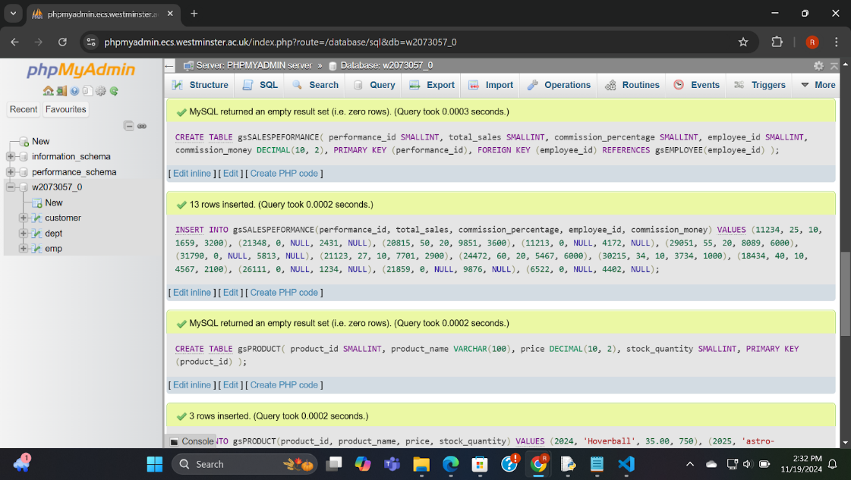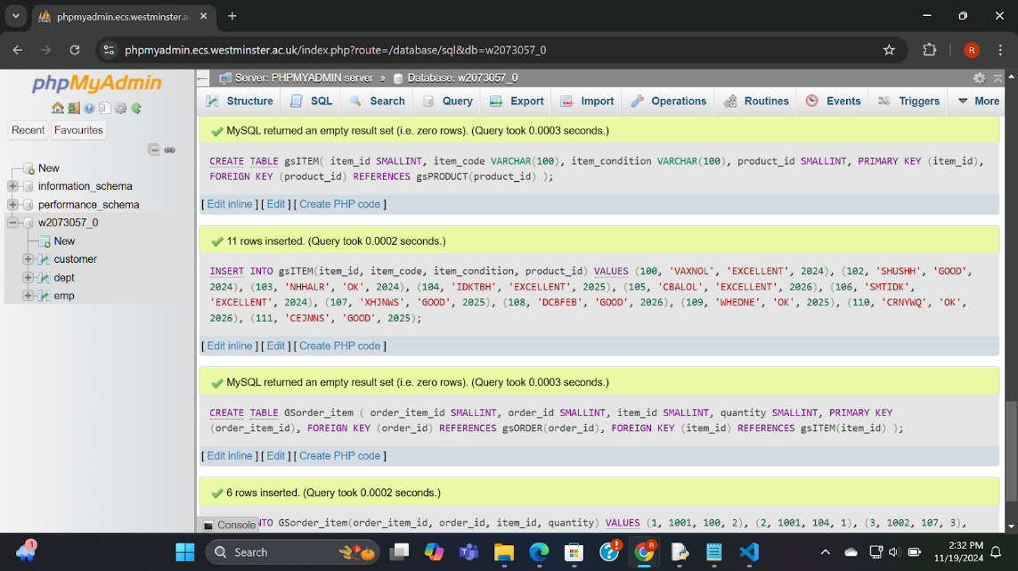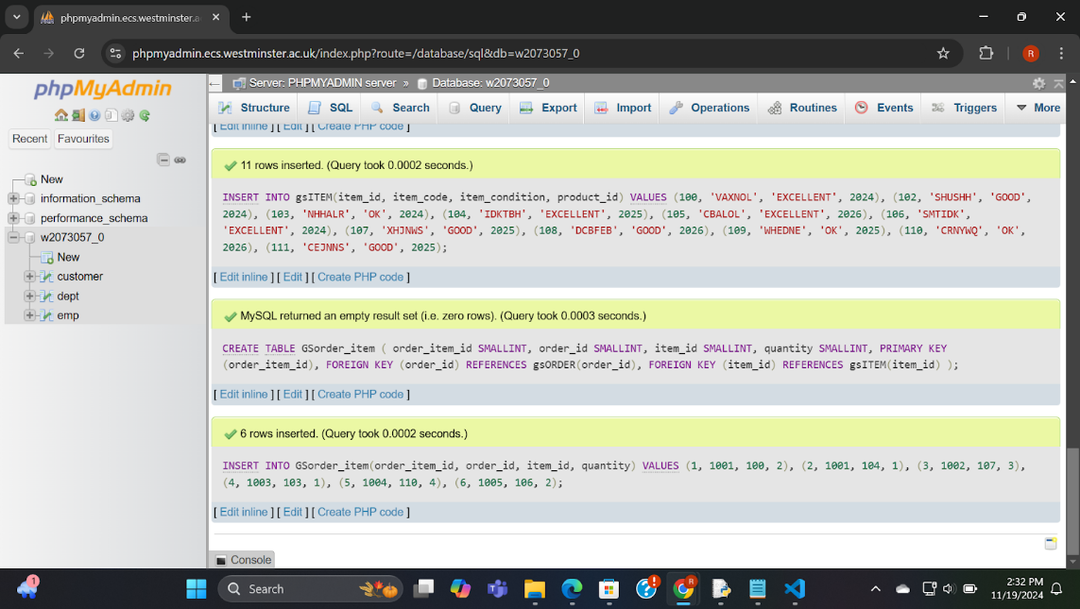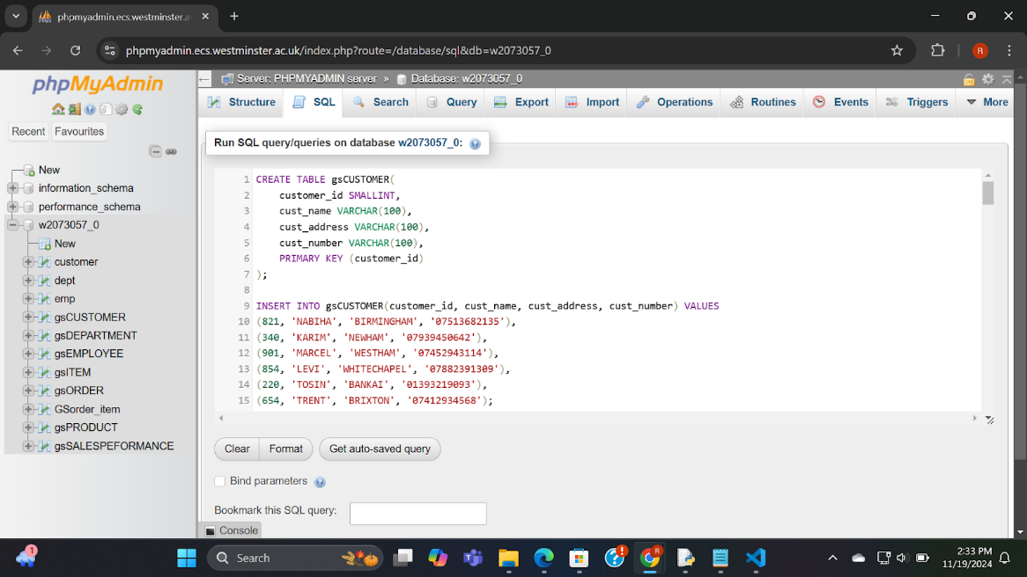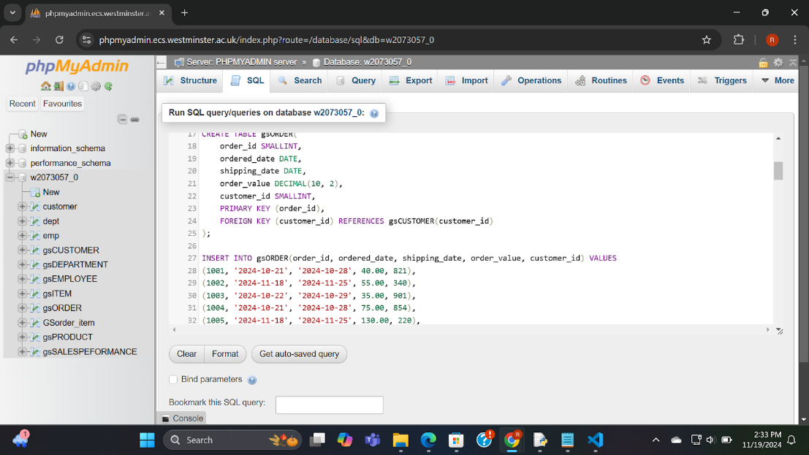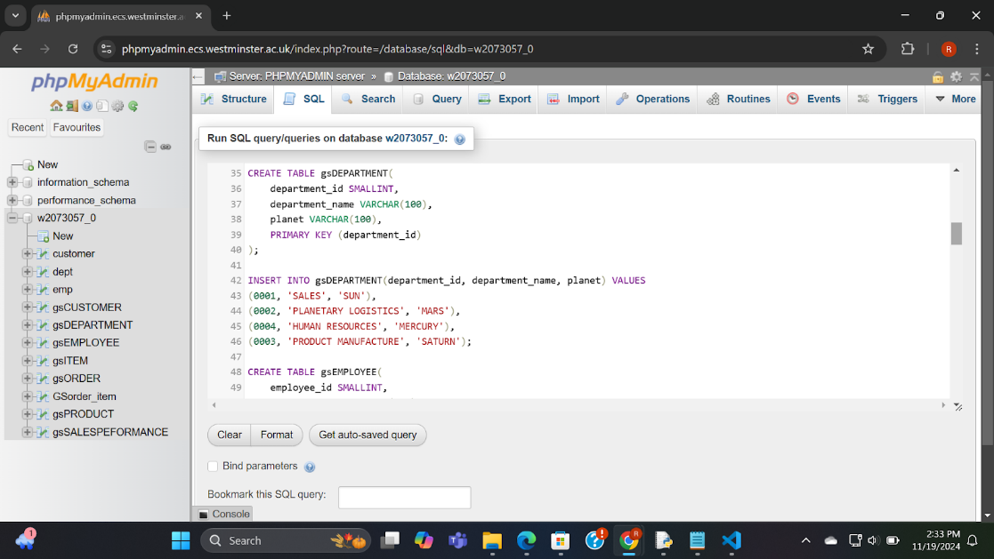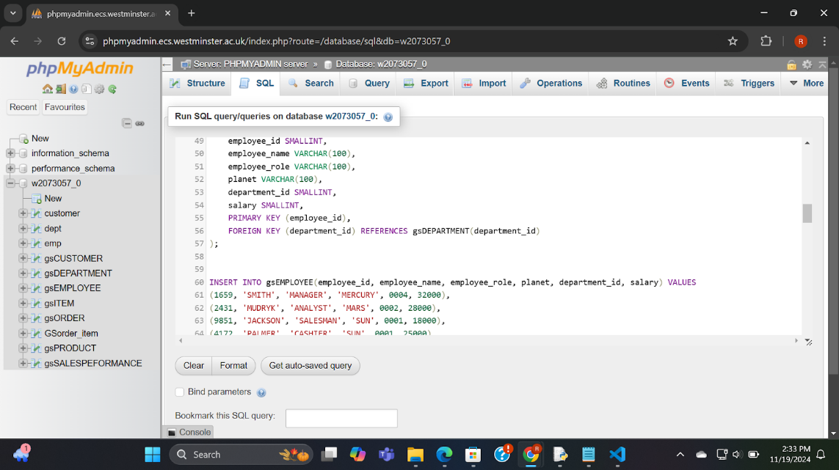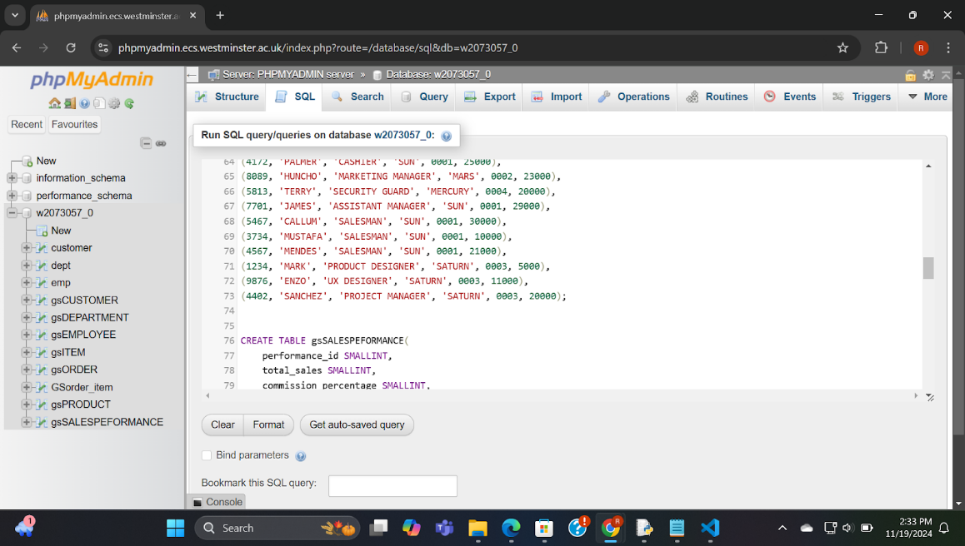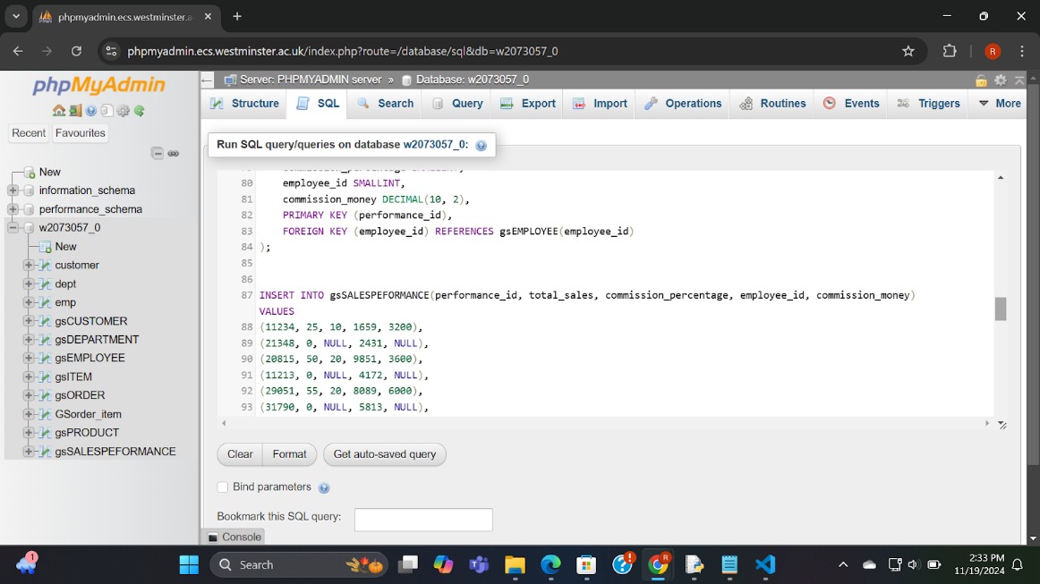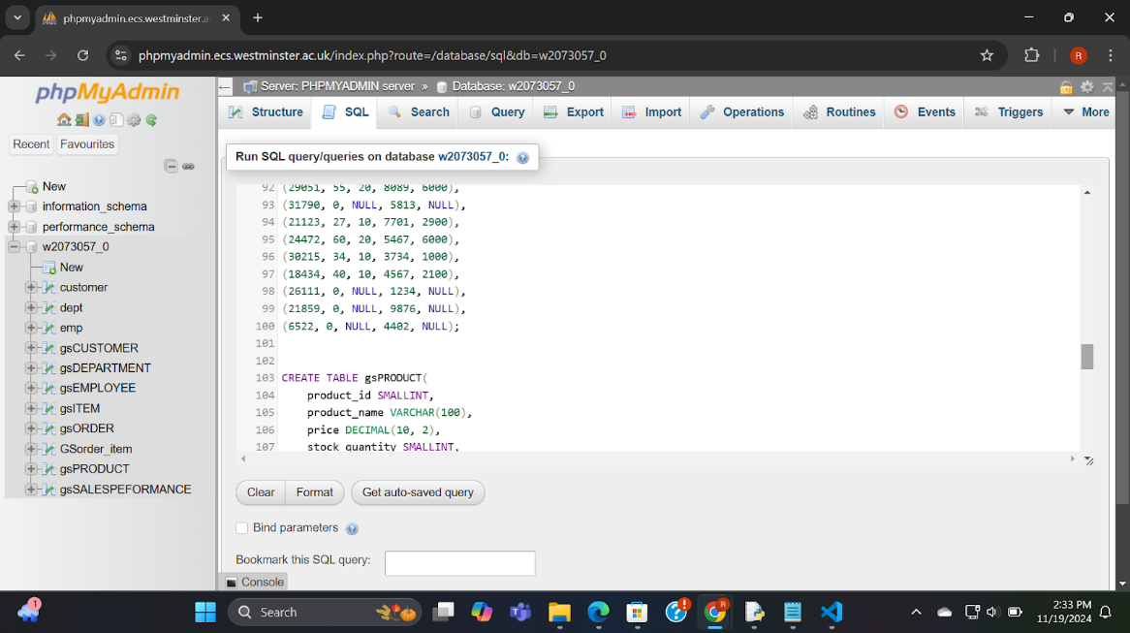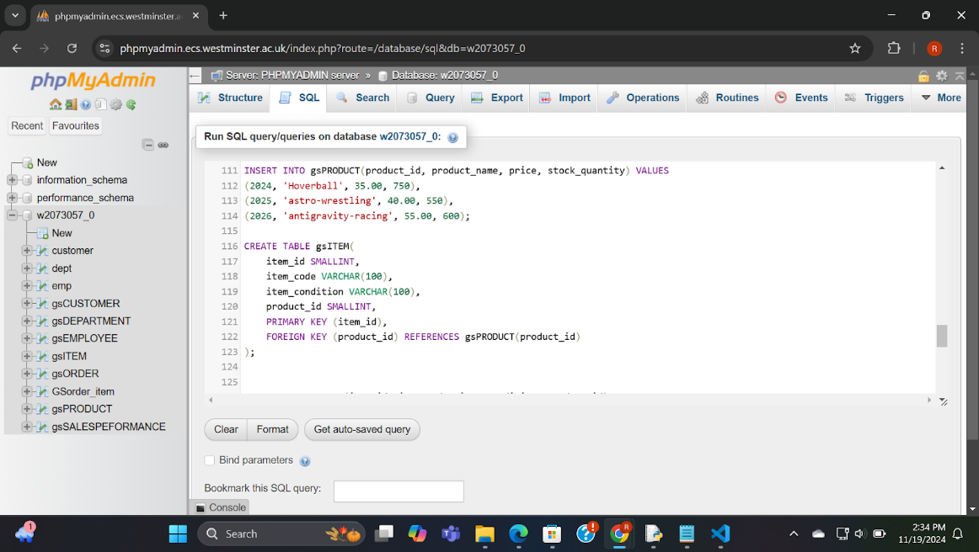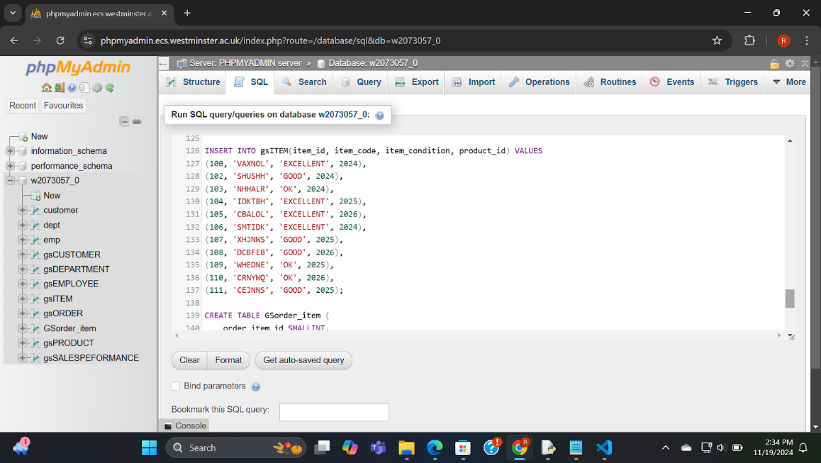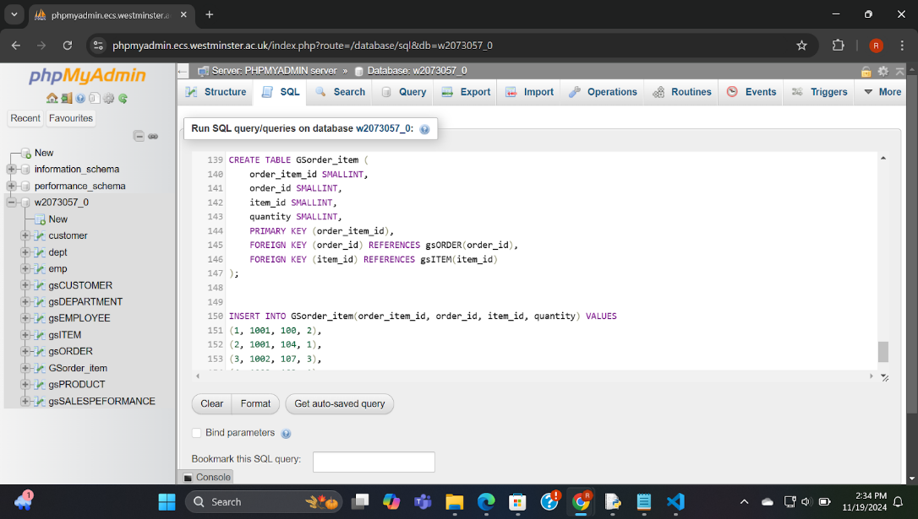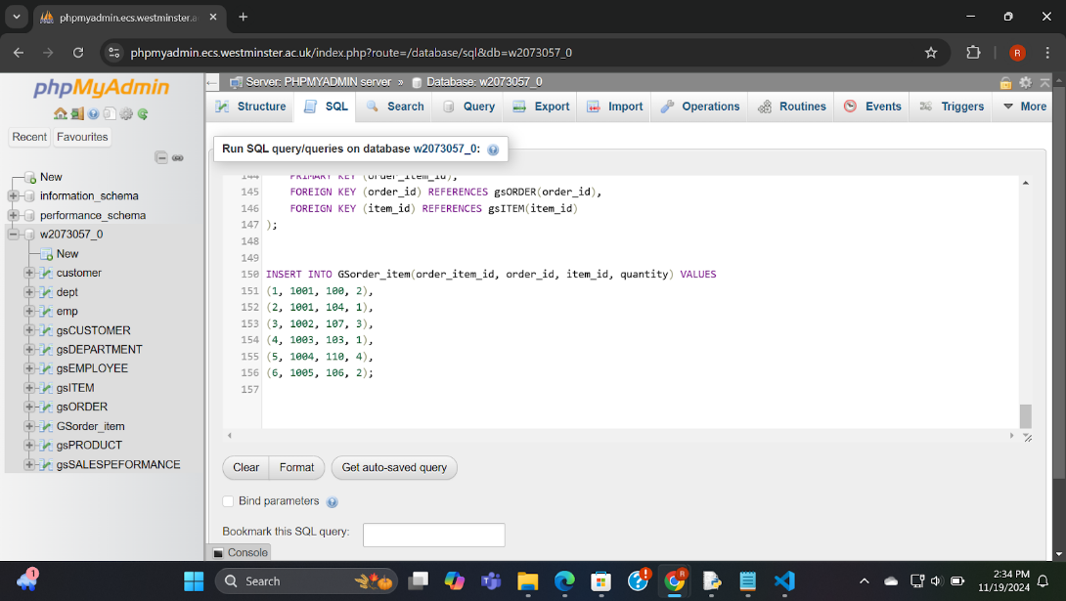

QUERIES :

|  |  |  |  |  |
| --- | --- | --- | --- | --- |
| Query NO | Purpose | Tables involved | SQL | Correct execution |
| 1 | Listing all order id with customer details | 2 tables - gsORDER,  gsCUSTOMER | SELECT order_id, ordered_date,shipping_date,order_value,cust_name,cust_address,cust_number  FROM gsORDER, gsCUSTOMER  WHERE gsORDER.customer_id = gsCUSTOMER.customer_id; | YES/NO |
| 2 | This query lists the total sales for each employee along with their role and department name, only if the commission is not null. | 3 tables - gsEMPLOYEE ,gsDEPARTMENT,gsSALESPEFORMANCE | SELECT  employee_name,employee_role,department_name,total_sales  FROM gsEMPLOYEE, gsDEPARTMENT, gsSALESPEFORMANCE  WHERE gsEMPLOYEE.department_id = gsDEPARTMENT.department_id AND gsEMPLOYEE.employee_id = gsSALESPEFORMANCE.employee_id AND gsSALESPEFORMANCE.commission_money IS NOT NULL; | YES/NO |
| 3 | Displays employee id and name for all employees with a salary greater than 20,000 | 1 table - gsEMPLOYEE | SELECT employee_id , employee_name  FROM gsEMPLOYEE  WHERE salary > 20000 ; | YES/NO |
| 4 | This query retrieves product names and their ordered quantities, showing the number of items ordered for each product. | 3- gsPRODUCT,gsITEM,GSorder_item | SELECT product_name,item_code,quantity  FROM gsPRODUCT, gsITEM, GSorder_item  WHERE gsPRODUCT.product_id = gsITEM.product_id AND gsITEM.item_id = GSorder_item.item_id; | YES/NO |
| 5 | Query to calculate the total salary and total commission of employees in each department: | 3 tables- gsDEPARTMENT,gsEMPLOYEE, gsSALESPEFORMANCE | SELECT gsDEPARTMENT.department_name, SUM(gsEMPLOYEE.salary) AS total_salary,SUM(gsSALESPEFORMANCE.commission_money) AS total_commission  FROM gsDEPARTMENT  JOIN gsEMPLOYEE ON gsDEPARTMENT.department_id = gsEMPLOYEE.department_id  LEFT JOIN gsSALESPEFORMANCE ON gsEMPLOYEE.employee_id = gsSALESPEFORMANCE.employee_id  GROUP BY gsDEPARTMENT.department_name; | YES/NO |
| 6 | This query returns the product name, stock quantity, and total number of items ordered, calculated from the item_order table. | 3 tables - gsPRODUCT , gsITEM , GSorder_item | SELECT product_name,stock_quantity, SUM(quantity) AS total_ordered  FROM gsPRODUCT,gsITEM,GSorder_item  WHERE gsPRODUCT.product_id = gsITEM.product_id AND gsITEM.item_id = GSorder_item.item_id  GROUP BY gsPRODUCT.product_name, gsPRODUCT.stock_quantity; | YES/NO |
| 7 | This query lists employees who have earned commission, displaying their employee names, roles, and commission details. | 2 tables - gsEMPLOYEE, gsSALESPEFORMANCE | SELECT employee_name,employee_role,commission_percentage,commission_money  FROM gsEMPLOYEE, gsSALESPEFORMANCE  WHERE gsEMPLOYEE.employee_id = gsSALESPEFORMANCE.employee_id AND gsSALESPEFORMANCE.commission_money IS NOT NULL; | YES/NO |
| 8 | Displays the average salary of a galactic sport employee | 1 table - gsEMPLOYEE | SELECT AVG(salary)  FROM gsEMPLOYEE ; | YES/NO |
| 9 | Shows the department name and id for the department that is represented by the planet “MARS” | 1 table- gsDEPARTMENT | SELECT department_name , department_id  FROM gsDEPARTMENT  WHERE planet = 'MARS'; | YES/NO |
| 10 | Shows the sum of all the employees salary | 1 table - gsEMPLOYEE | SELECT SUM(salary)  FROM gsEMPLOYEE ; | YES/NO |

QUERY 1 AND OUTPUT: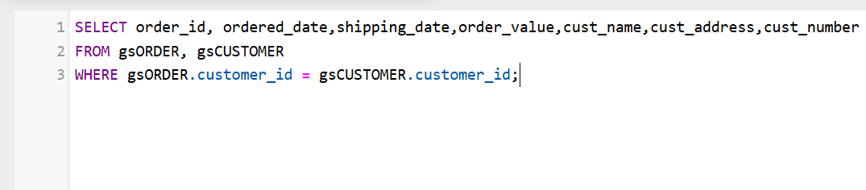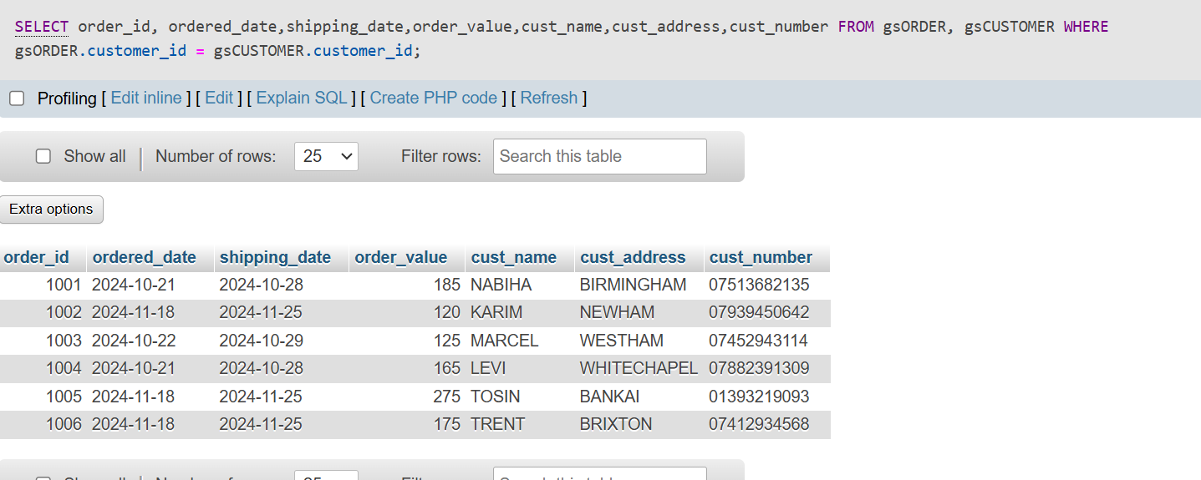

QUERY 2 AND OUTPUT: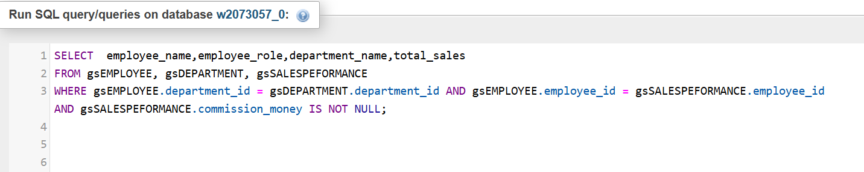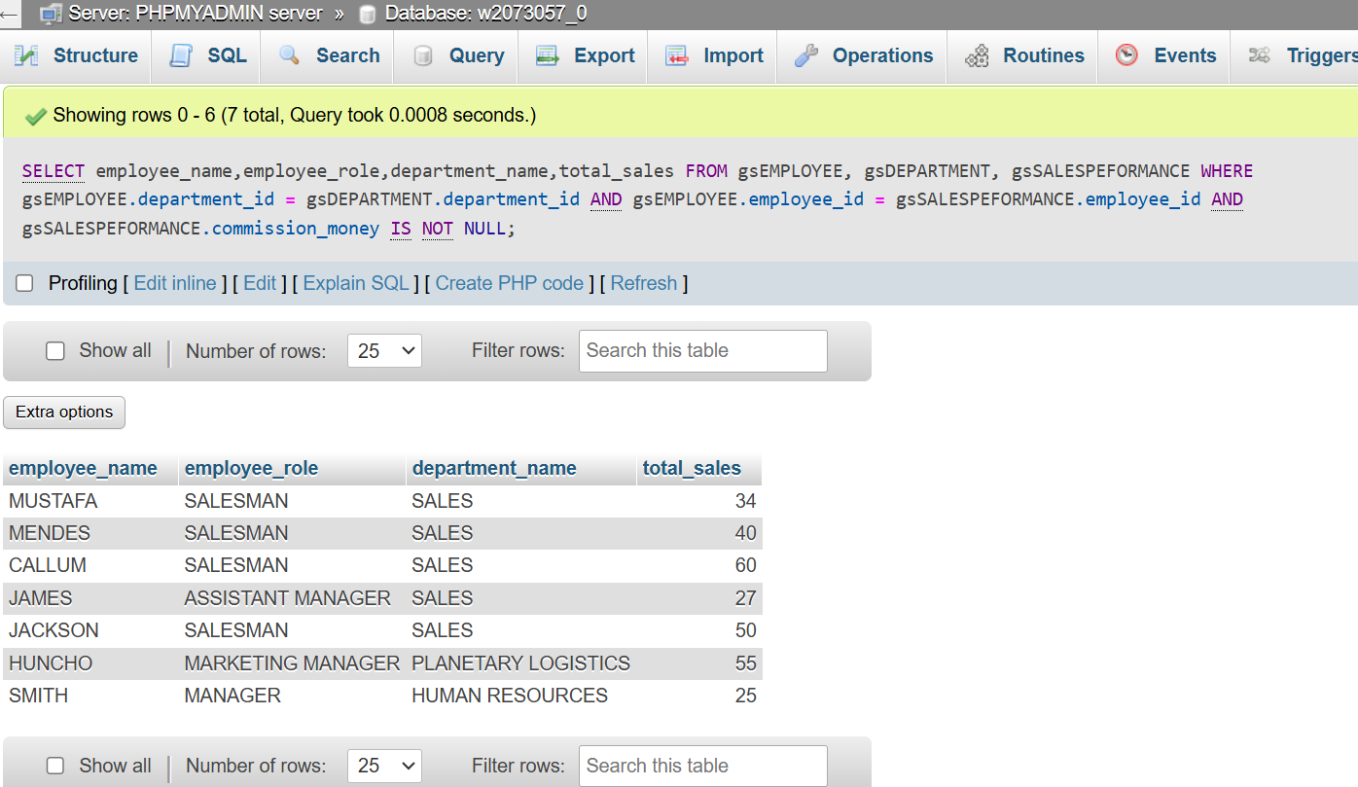

QUERY 3 AND OUTPUT:

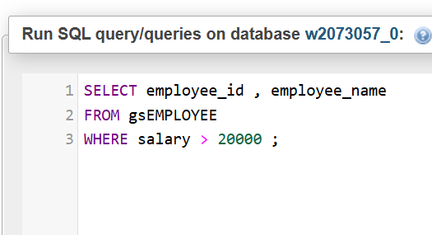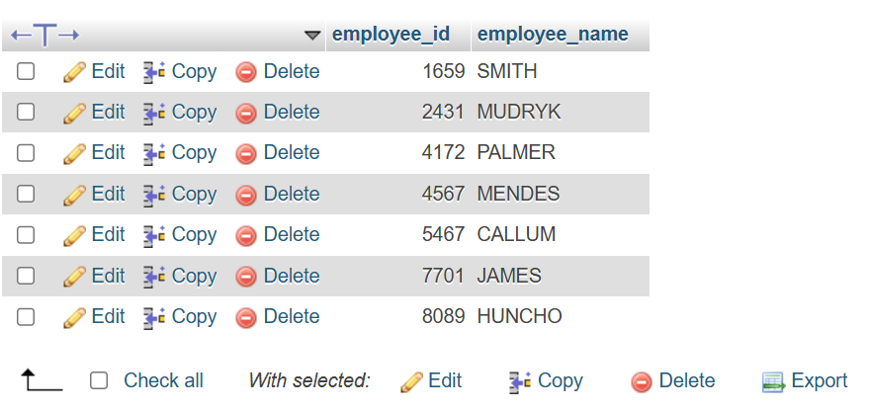

QUERY 4 AND OUTPUT:

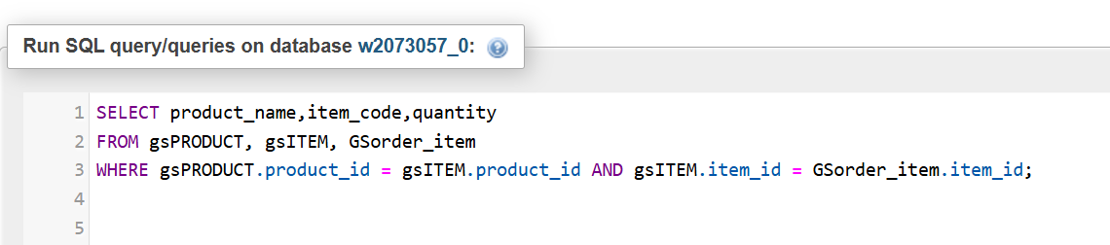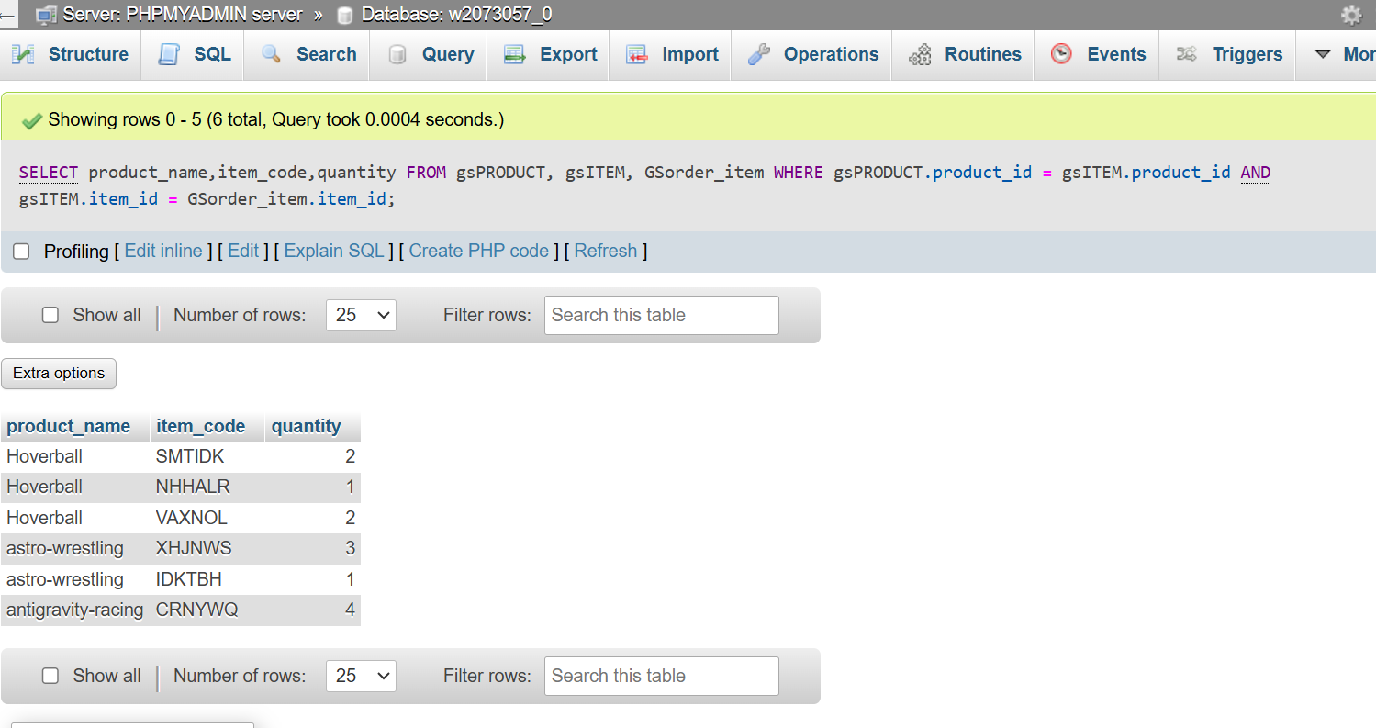

QUERY 5 AND OUTPUT:

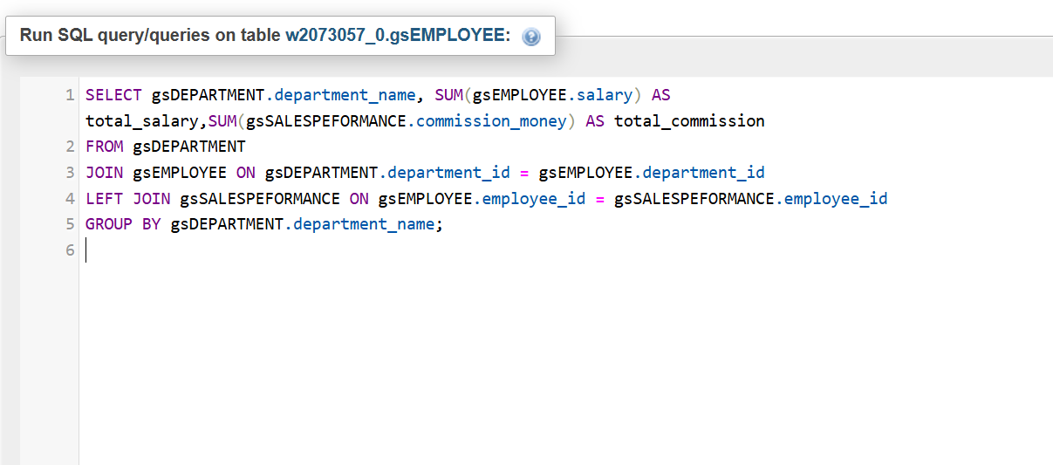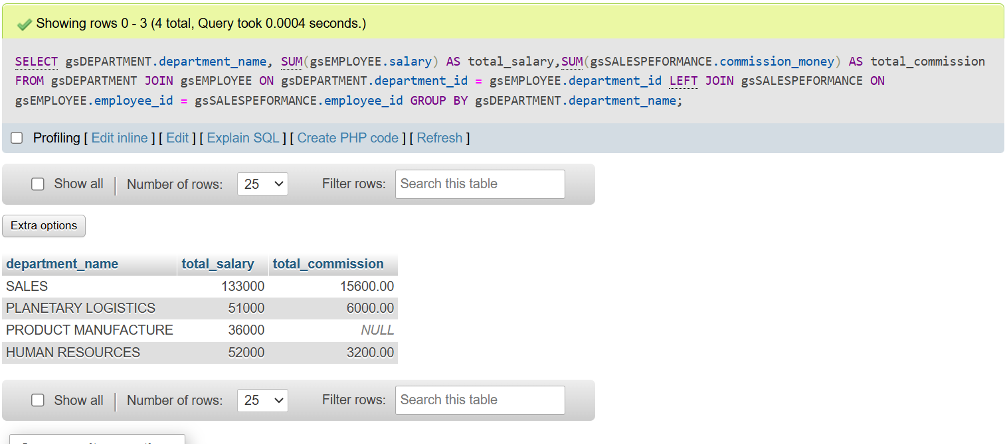

QUERY 6 AND OUTPUT:

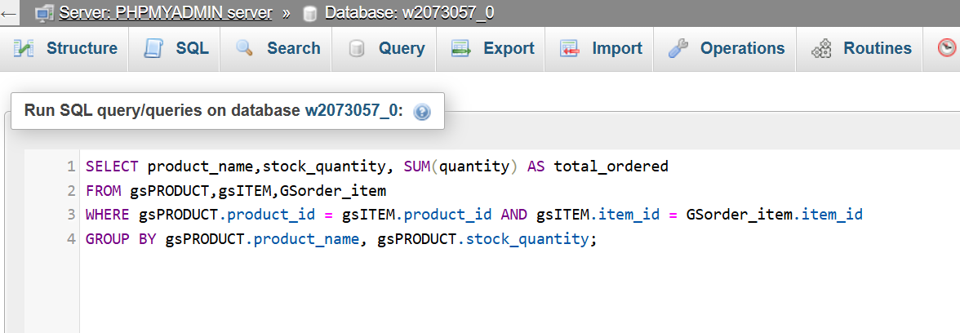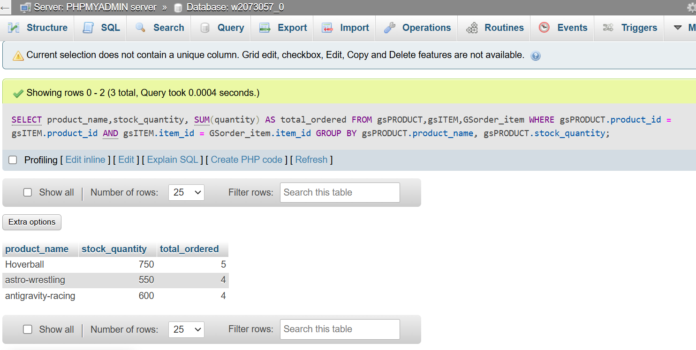

QUERY 7 AND OUTPUT:

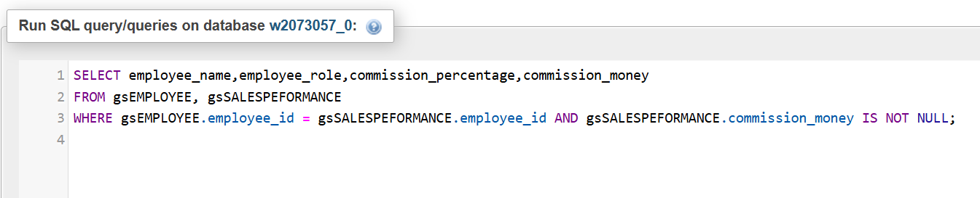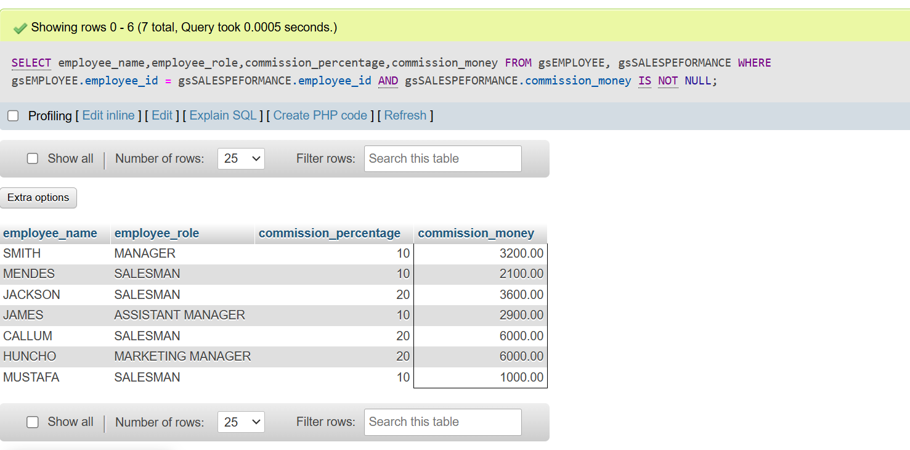

QUERY 8 AND OUTPUT:

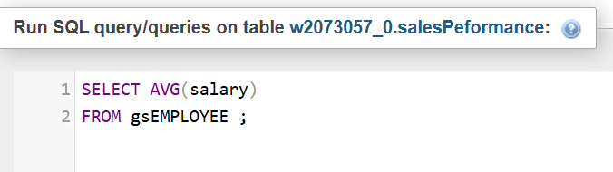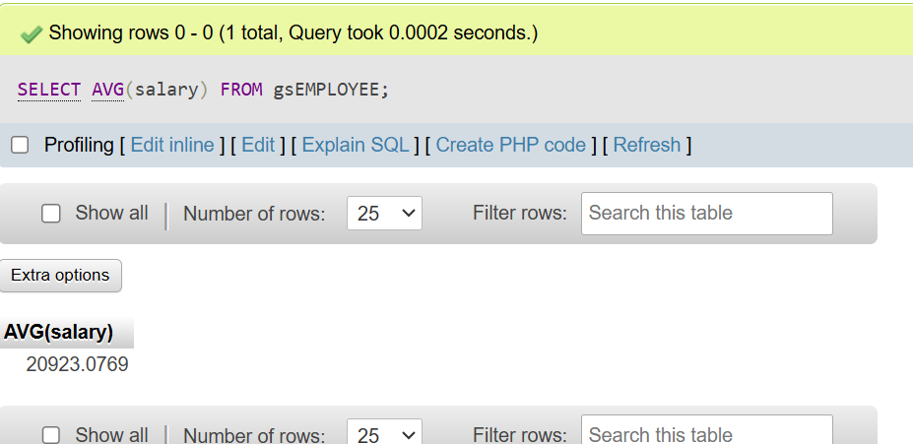

QUERY 9 AND OUTPUT:

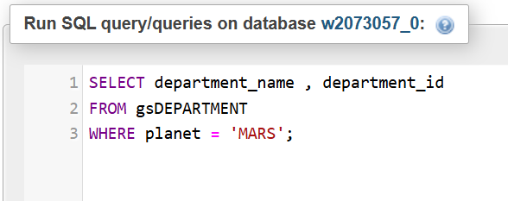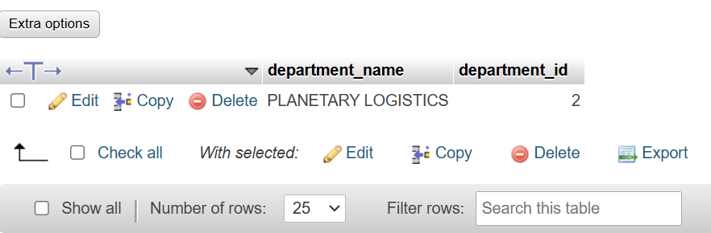

QUERY 10 AND OUTPUT:

